Lecture 3.

Classification, morphology and ultrastructure of fungi, protozoa and viruses. Prions

The purpose of the lecture: To inform students about eukaryotic microorganisms, to acquaint them with the classification, morphology and structural features of fungi, as well as species that are pathogenic to humans. To inform them about the classification, morphology and ultrastructure of primates, as well as the representatives of the pathogen. Explain the classification, morphology and ultrastructure of viruses, to acquaint them with the general characteristics of prions.
Lecture plan:
1. Morphology and ultrastructure of eukaryotic microorganisms
- Classification, morphology, ultrastructure of fungi.
- Pathogenic types of fungi for humans: advanced (Zygomycota, Ascomycota, Basidiomycota) and immature (Deuteromycota) fungi.
- Classification, morphology, ultrastructure of protozoa.
- Pathogenic species of protozoa for humans: Sarcomastigophora, Apicomplexa, Ciliophora, Microspora types.
2. Classification, morphology and ultrastructure of viruses.
3. Pathogenic types of viruses for humans: DNA and RNA viruses.
4. Reproduction of viruses. Features of reproduction in viruses containing DNA and RNA. Viruses with positive and negative RNA genomes.
- Types of interaction of viruses with the host cell: productive, abortive, integrative.
- Virogenia and its mechanism.
5. Prions and viroids

Medical Mycology
Mycology is the study of fungi, which are eukaryotic organisms that evolved in tandem with the animal kingdom. However, unlike animals, most fungi are nonmotile and possess a rigid cell wall. Unlike plants, fungi are nonphotosynthetic. Approximately 80,000 species of fungi have been described, but only about 400 are medically important, and less than 50 are responsible for more than 90% of the fungal infections of humans and other animals. Rather, most species of fungi are beneficial to humankind. They reside in nature and are essential in breaking down and recycling organic matter. Some fungi greatly enhance our quality of life by contributing to the production of food and spirits, including cheese, bread, and beer. Other fungi have served medicine by providing useful bioactive secondary metabolites such as antibiotics (eg, penicillin) and immunosuppressive drugs (eg, cyclosporine). Fungi have also been exploited by geneticists and molecular biologists as model systems
for the investigation of a variety of eukaryotic processes, including cellular growth and development. Overall, fungi exert their greatest economic impact as phytopathogens; the agricultural industry sustains huge crop losses every year as a result of fungal diseases of rice, corn, grains, and other plants.
Budding: A common mode of asexual reproduction, typical of yeasts. During mitosis, the parent cell wall protrudes outwardly and enlarges to form a nascent bud that contains the progeny nucleus. A fungal cell may produce single or multiple buds.
Conidia: Asexual reproductive structures (mitospores) produced either from the transformation of a vegetative yeast or hyphal cell or from a specialized conidiogenous cell, which may be simple or complex and elaborate. Conidia may be formed on specialized hyphae, termed conidiophores. Microconidia are small, and macroconidia are large or multicellular.
Arthroconidia (arthrospores): Conidia that result from the fragmentation of hyphal cells (Figure 45-1).
Blastoconidia (blastospores): Conidia that are produced by budding (eg, yeasts).
Chlamydospores (chlamydoconidia): Large, thick-walled, usually spherical conidia produced from terminal or intercalary hyphal cells.
Phialoconidia: Conidia that are produced by a “vaseshaped” conidiogenous cell termed a phialide (eg,Aspergillus fumigatus).
Dematiaceous fungi: Fungi whose cell walls contain melanin, which imparts a brown to black pigment.
Dimorphic fungi: Fungi that have two growth forms, such as a mold and a yeast, which develop under different growth conditions (eg, Blastomyces dermatitidis forms hyphae in vitro and yeasts in tissue).
Hyphae: Tubular, branching filaments (2–10 μm in width) of fungal cells, the mold form of growth. Most hyphal cells are separated by porous cross-walls or septa, but in the Order Mucorales, the hyphae are characteristically sparsely septate. Vegetative or substrate hyphae anchor the colony and absorb nutrients. Aerial hyphae project above the colony and bear the reproductive structures.
Anamorph: The mitotic or asexual reproductive state of a fungus. Anamorphic fungal taxa are identified on the basis of their asexual reproductive structures (ie, mitospores).
Mold: Hyphal or mycelial colony or form of growth.
Mycelium: Mass or mat of hyphae, mold colony.
Teleomorph: The sexual reproductive state of a fungus, which involves plasmogamy, karyogamy, and meiosis.
Pseudohyphae: Chains of elongated buds or blastoconidia; the septations between cells are constricted.
Septum: Hyphal cross-wall, typically perforated.
Sporangiospores: Asexual structures characteristic of the Order Mucorales; they are mitotic spores produced within an enclosed sporangium, often supported by one sporangiophore.
Spore: A specialized propagule with enhanced survival value, such as resistance to adverse conditions or structural features that promote dispersion. Spores may result from asexual (eg, conidia, sporangiospores) or sexual (see below) reproduction.
Sexual spores: During sexual reproduction, haploid cells of compatible strains mate through a process of plasmogamy, karyogamy, and meiosis.
Ascospores: In the Phylum Ascomycota, following meiosis, four to eight meiospores form within an ascus.
Basidiospores: In the Phylum Basidiomycota, following meiosis, four meiospores usually form on the surface of a specialized structure, a club-shaped basidium.
Zygospores: In the Order Mucorales, following meiosis, a large, thick-walled zygospore develops.
Yeasts: Unicellular, spherical to ellipsoid (3–15 μm) fungal cells that usually reproduce by budding.

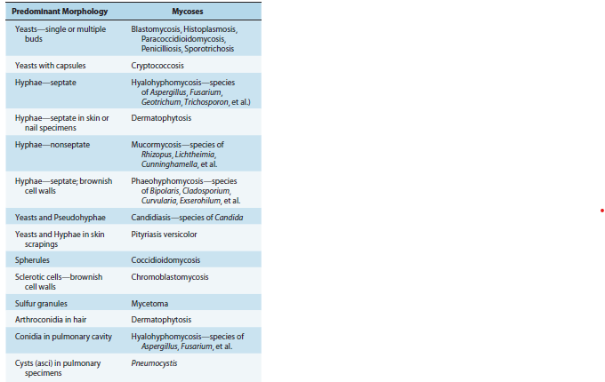
The Major Mycoses and Causative Fungi
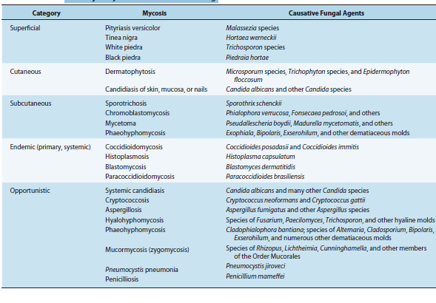
Fungal Structures Observed in Microscopic Examinations of Clinical Specimens

Fungi have two basic growth forms, as molds and yeasts. Growth in the mold (or mould) form occurs by the production of multicellular branching cylindrical tubules called hyphae that vary in diameter from 2 to 10 μm. Hyphae are extended by apical elongation due to the production of new cell wall growth at the hyphal tips. The mass of intertwined hyphae that accumulates during active growth is a mycelium. Some hyphae are divided into cells by cross-walls or septa, which typically form at regular intervals during hyphal growth. However, members of the Order Mucorales produce hyphae that are rarely septated. Vegetative or substrate hyphae penetrate the supporting medium, anchor the colony, and absorb nutrients. In contrast, aerial hyphae project above the surface of the mycelium and usually bear the reproductive structures of the mold. When a mold is isolated from a clinical specimen, its growth rate, macroscopic appearance, and microscopic morphology are usually sufficient to determine its genus and species. The most helpful phenotypic features are the ontogeny and morphology of the asexual reproductive spores, or conidia.
Yeasts are single cells, usually spherical to ellipsoid in shape and varying in diameter from 3 to 15 μm. Most yeasts reproduce by budding, which is initiated by a lateral or terminal protrusion of new cell wall growth that enlarges during mitosis. One or more replicated nuclei enter the nascent bud, which subsequently forms a septum and separates from the parent cell. Some species produce buds that characteristically fail to detach and become elongated; this continuation of the budding process produces chains of elongated yeast cells called pseudohyphae. Yeast colonies are usually soft, opaque, 1–3 mm in size, and cream colored. The colonies and microscopic morphology of many species of yeasts appear quite similar, but they can be identified by physiologic tests andb a few key morphologic differences. Some species, including several pathogens, are dimorphic and capable of growth as a yeast or mold depending on environmental conditions, such as temperature or available nutrients.
The life cycles of fungi are remarkably versatile. Depending on the fungus, the predominant nuclear chromosomal count may be haploid or diploid. Some species exist entirely by clonal growth or asexual reproduction, and barring spontaneous mutations, every cell will be a genetic clone. Many other species are capable of sexual reproduction, which may or may not require genetically different partners for mating and meiosis. Asexual as well as sexual reproduction can result in the production of spores, which enhance fungal survival. Spores are usually dormant, readily dispersed, more resistant to adverse conditions, and germinate to form vegetative cells when conditions for growth are favorable. Spores derived from asexual or sexual reproduction are termed anamorphic or teleomorphic, respectively. Like vegetative cells, asexual spores are mitotic progeny (ie, mitospores). The medical fungi produce two major types of asexual spores, conidia, which are produced by most pathogenic fungi, and, in the Order Mucorales, sporangiospores (see below and Glossary). Informative features of spores include their ontogeny (some molds produce complex conidiogenic structures) as well as their morphology (size, shape, texture, color, and unicellularity or multicellularity). In some fungi, vegetative cells may transform into conidia (eg, arthroconidia, chlamydospores) .In others, conidia are produced by a conidiogenous cell, such as a phialide, which itself may be attached to a specialized hypha called a conidiophore. Sporangiospores result from mitotic replication and spore production within a sac-like structure called a sporangium, which is supported by a sporangiophore.
Certain fungal properties are essential but not necessarily sufficient for pathogenicity, such as the ability to proliferatenin the mammalian host. Many virulence factors have evolved to enable pathogenic fungi to withstand or circumvent the defenses and stressful environment of the host. Some of these virulence determinants include morphological transformations, genetic “switching” of metabolic processes in response to the host environment, the production of surface adhesins that bind to host cell membranes, the secretion of enzymes that attack host substrates (eg, catalase, aspartyl proteinases, phospholipases), cell wall components that resist phagocytosis
(eg, α-(1,3)-glucan, melanin, the capsule of Cryptococcus), and the formation of biofilms. Specific examples are provided in this chapter’s descriptions of several mycoses.
Fungi have an essential rigid cell wall that determines their shape and protects them from osmotic and other environmental stresses. Cell walls are composed largely of carbohydrate layers—long chains of polysaccharides—as well as glycoproteins and lipids. Some sugar polymers are found in the cell walls of many fungi, such as chitin (an unbranched polymer of β-1,4-linked N-acetylglucosamine); glucans, which are glucose polymers (eg, α-1,3-glucan, β-1,3-glucan, and β-1,6-glucan); and mannans, polymers of mannose (eg, α-1,6-mannose). These components are cross-linked to from a multilayered cell wall matrix. In addition, other polysaccharides may be unique to specific fungal species and therefore useful for identification. During infection, fungal cell walls exert important pathobiology properties. The surface components of the cell wall mediate attachment of the fungus to host cells. Specific fungal cell wall moieties bind to pattern recognition receptors on host cell membranes, such as certain Toll-like receptors, to stimulate innate immune responses.
Cell wall glucans and other polysaccharides may activate the complement cascade and provoke an inflammatory reaction. Most of these polysaccharides are poorly degraded by the host and can be detected with special histologic stains. Cell walls also release immunodominant antigens that may elicit cellular immune responses and diagnostic antibodies. In addition, some yeasts and molds are described as dematiaceous because their cell walls contain melanin, which imparts a brown or black pigment to the fungal colony. Several studies have shown that melanin protects these fungi from host defenses.
Taxonomy
Fungi were initially classified into phyla based largely on their modes of sexual reproduction and phenotypic data. These methods have been supplanted by molecular systematics, which more accurately reflect phylogenetic relationships. There is some ambiguity about the divergence of fungi and animals and their extant ancestors. The lower fungi were assigned to the Phylum Zygomycota, but this phylum was shown to be polyphyletic and has been replaced by the Phylum Glomerulomycota, four subphyla and two zoopathogenic Orders, the Mucorales and the Entomophthorales. However, the two largest phyla, Ascomycota and Basidiomycota, are well supported by phylogenetic analyses. All three of these phyla contain yeasts, molds, and dimorphic species. The Phylum Ascomycota (or ascomycetes) includes more than 60% of the known fungi and about 85% of the human pathogens. Most of the other pathogenic fungi are members of the Phylum Basidiomycota (basidiomycetes) or the Order Mucorales. These medically relevant taxa are distinguished by their modes of reproduction. Sexual reproduction typically occurs when mating-compatible strains of a species are stimulated by pheromones to undergo plasmogamy, karyogamy (nuclear fusion), and meiosis, resulting in the exchange of genetic information and the formation of haploid sexual spores.
Medical Parasitology
The parasites covered in this chapter are categorized into two major groups: parasitic protozoa and parasitic helminths. Protozoa are unicellular eukaryotes that form an entire kingdom. Classifying protozoan parasites into taxonomic groups is an ongoing process, and their status is often in a state of flux. For this reason, this chapter separates the parasitic protozoa into four traditional groups based on their means of locomotion and mode of reproduction: flagellates, amebae, sporozoa, and ciliates. (1) Flagellates have one or more whiplike flagella and, in some cases, an undulating membrane (eg, trypanosomes). These include intestinal and genitourinary flagellates (Giardia and Trichomonas, respectively) and blood and tissue flagellates (Trypanosoma and Leishmania). (2) Amebae are typically ameboid and use pseudopodia or protoplasmic flow to move. They are represented in humans by species of Entamoeba, Naegleria, and Acanthamoeba. (3) Sporozoa undergo a complex life cycle with alternating sexual and asexual reproductive phases. The human parasites Cryptosporidium, Cyclospora, and Toxoplasma and the malarial parasites (Plasmodium species) are all intracellular parasites. (4) Ciliates are complex protozoa bearing cilia distributed in rows or patches, with two kinds of nuclei in each individual. Balantidium coli, a giant intestinal ciliate of humans and pigs, is the only human parasite representative of this group, and because the disease is considered rare, it is not covered in this chapter. Formerly listed with the sporozoa, because they possess polar filaments within a spore, microsporidia include more than 1000 species of intracellular parasites that infect invertebrates (mostly insects) and vertebrate hosts. In humans, microsporidians are opportunistic parasites of immunocompromised patients, including those undergoing chemotherapy and organ transplants. Pneumocystis jiroveci was long considered a protozoan parasite but has been shown to be a member of the fungi rather than the protozoa. It causes interstitial plasma cell
pneumonitis in immunosuppressed individuals and is considered an opportunistic pathogen. Parasitic helminths, or worms of humans, belong to two phyla: Nematoda (roundworms) and Platyhelminthes (flatworms). (1) Nematodes are among the most speciose and diverse animals. They are elongated and tapered at both ends, round in cross-section, and unsegmented. They have only a set several medically important protozoan parasites by the organ system they infect, the mode of infection, diagnosis, treatment, and geographic location.
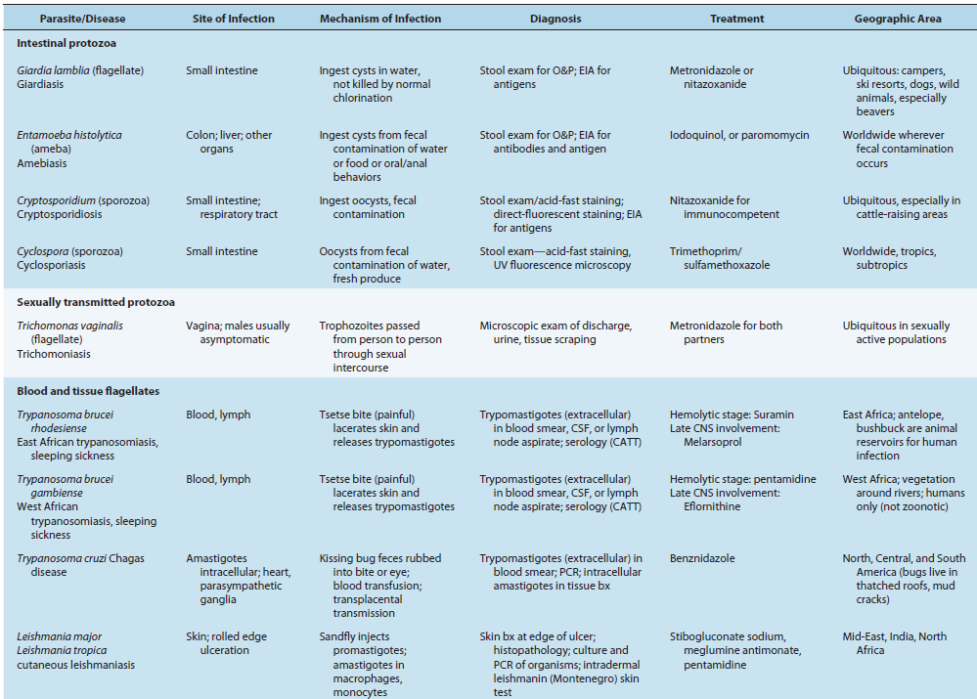

Synopsis of Protozoan Infections by Organ System

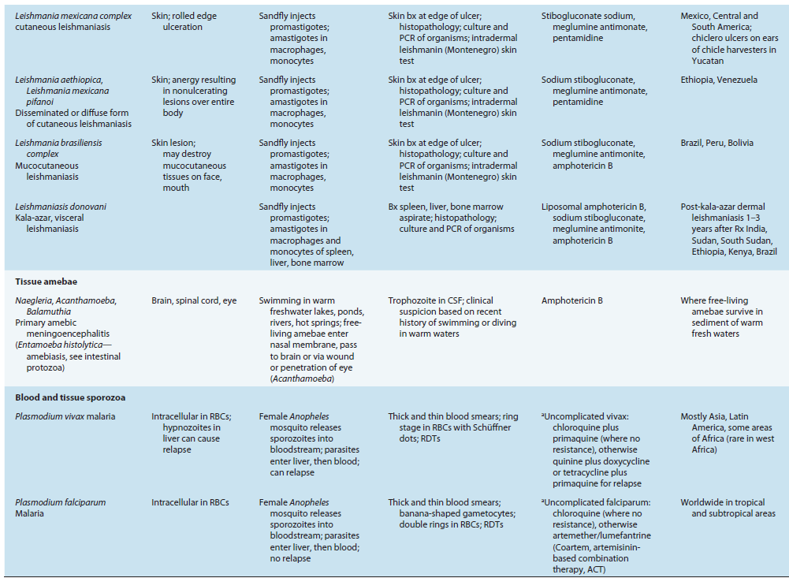

Parasitic protozoa covered in this chapter are grouped into the flagellates, amebae, sporozoa, and ciliates. Flagellates and amebae multiply by binary fission; sporozoans reproduce by a process known as merogony (also called schizogony) in which the nuclei replicate prior to cytokinesis. Sporozoans (Cryptosporidium, Plasmodium, Toxoplasma) undergo sexual recombination, which leads to genomic and antigenic variation. Protozoa can multiply quickly (on the order of several hours) in the host and can cause a rapid onset of symptoms. Intestinal infections are acquired by ingestion of an environmentally resistant cyst (or oocyst) form; blood infections are vectorborne.
Infections by intracellular protozoa (Trypanosoma cruzi, Leishmania spp., Cryptosporidium, Toxoplasma, and Plasmodium) are difficult to treat because drugs must cross plasma membranes. No vaccines are available for any human parasitic disease. Latent infections occur with Toxoplasma (parasites in tissue cysts are called bradyzoites) and Plasmodium vivax and Plasmodium ovale (parasites in liver tissue are called hypnozoites). In disseminated protozoal infections, fever and flulike symptoms
occur and are nonspecific. Some parasitic protozoa are able to evade the host’s immune response because they are intracellular and/or undergo antigenic variation.
Parasitic Protozoa
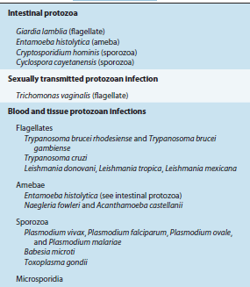

General Properties of Viruses
• Viruses are the smallest infectious agents and contain only one type of nucleic acid (DNA or RNA).
• Known viruses are highly diverse, varying in size, shape, and genetic content; some types possess a lipid envelope.
• Viruses are classified into groups, designated virus families, based on common properties, such as virion morphology, genome structure, virus protein properties, and strategies of replication.
• Viruses are obligate intracellular parasites and multiply only in living cells. The viral nucleic acid encodes virusspecific products, and the host cell provides energy, biochemical precursors, and biosynthetic machinery.
• Steps in viral replication include attachment to a cell via binding to specific receptors on the cell surface, entry into the cell, uncoating of the viral genome, regulated expression of viral transcripts, synthesis of viral proteins, replication of viral genomic nucleic acid, assembly of new progeny viruses, and release of new virions from the cell. The duration of replication cycles varies widely among different virus types. The infected cells may be killed or may survive with little damage. Not all infection lead to new progeny virus.
• New viral diseases are emerging, termed “emerging infectious diseases,” as new agents are recognized, known agents evolve and spread, and new host populations become infected.
• Some viruses are potential bioterrorism agents based on ease of host-to-host transmission and mortality rates.

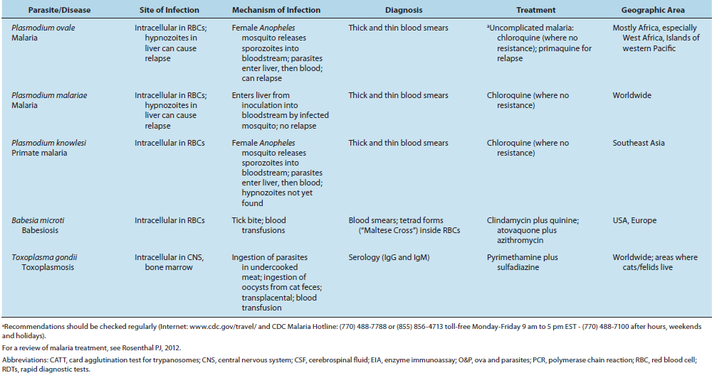
Schematic diagrams of viruses with icosahedral and helical symmetry. Indicated viral components are described below.
Capsid: The protein shell, or coat, that encloses the nucleic acid genome.
Capsomeres: Morphologic units seen in the electron microscope on the surface of icosahedral virus particles. Capsomeres represent clusters of polypeptides, but the morphologic units do not necessarily correspond to the chemically defined structural units.
Defective virus: A virus particle that is functionally deficient in some aspect of replication.
Envelope: A lipid-containing membrane that surrounds some virus particles. It is acquired during viral maturation by a budding process through a cellular membrane (see Figure 29-3). Virus-encoded glycoproteins are exposed on the surface of the envelope. These projections are called peplomers.
Nucleocapsid: The protein–nucleic acid complex representing the packaged form of the viral genome. The term is commonly used in cases in which the nucleocapsid is a substructure of a more complex virus particle.
Structural units: The basic protein building blocks of the coat. They are usually a collection of more than one nonidentical protein subunit. The structural unit is often referred to as a protomer.
Subunit: A single folded viral polypeptide chain.
Virion: The complete virus particle. In some instances (eg, papillomaviruses, picornaviruses), the virion is identical with the nucleocapsid. In more complex virions (herpesviruses, orthomyxoviruses), this includes the nucleocapsid plus a surrounding envelope. This structure, the virion, serves to transfer the viral nucleic acid from one cell to another.
EVOLUTIONARY ORIGIN OF VIRUSES
The origin of viruses is not known. There are profound differences among the DNA viruses, the RNA viruses, and viruses that use both DNA and RNA as their genetic material during different stages of their life cycle. It is possible that different
types of agents are of different origins. Two theories of viral origin can be summarized as follows:
1. Viruses may be derived from DNA or RNA nucleic acid components of host cells that became able to replicate autonomously and evolve independently. They resemble genes that have acquired the capacity to exist independently of the cell. Some viral sequences are related to portions of cellular genes encoding protein functional domains. It seems likely that at least some viruses evolved in this fashion.
2. Viruses may be degenerate forms of intracellular parasites. There is no evidence that viruses evolved from bacteria, although other obligately intracellular organisms (eg, rickettsiae and chlamydiae) presumably did so. However, poxviruses are so large and complex that they might represent evolutionary products of some cellular ancestor.
CLASSIFICATION OF VIRUSES
Basis of Classification
The following properties have been used as a basis for the classification of viruses. The amount of information available in each category is not the same for all viruses. Genome sequencing is now often performed early in virus identification, and comparisons with databases provide detailed information on the viral classification, predicted protein composition, and taxonomic relatedness to other viruses.
1. Virion morphology, including size, shape, type of symmetry, presence or absence of peplomers, and presence or absence of membranes.
2. Virus genome properties, including type of nucleic acid (DNA or RNA), size of the genome, strandedness (single or double), whether linear or circular, sense (positive, negative, ambisense), segments (number, size), nucleotide sequence, percent GC content, and presence of special features (repetitive elements, isomerization, 5′ terminal cap, 5′-terminal covalently linked protein, 3′-terminal poly(A) tract).
3. Genome organization and replication, including gene order, number and position of open reading frames, strategy of replication (patterns of transcription, translation), and cellular sites (accumulation of proteins, virion assembly, virion release).
4. Virus protein properties, including number, size, amino acid sequence, modifications (glycosylation, phosphorylation, myristoylation), and functional activities of structural and nonstructural proteins (transcriptase, reverse transcriptase, neuraminidase, fusion activities).
5. Antigenic properties, particularly reactions to various antisera.
6. Physicochemical properties of the virion, including molecular mass, buoyant density, pH stability, thermal stability, and susceptibility to physical and chemical agents, especially solubilizing agents and detergents.
7. Biologic properties, including natural host range, mode of transmission, vector relationships, pathogenicity, tissue tropisms, and pathology.

Families of Animal Viruses That Contain Members Able to Infect Humans
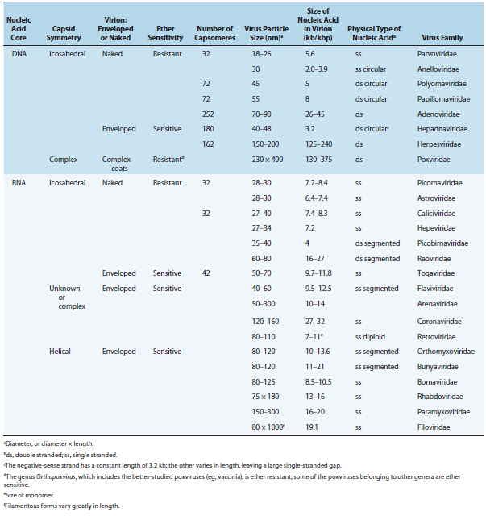
PRIONS
A number of remarkable discoveries in the past three decades have led to the molecular and genetic characterization of the transmissible agent causing scrapie, a degenerative central nervous system disease of sheep. Studies have identified a scrapie-specific protein in preparations from scrapie-infected brains of sheep that is capable of reproducing the symptoms of scrapie in previously uninfected sheep (Figure 1-2). Attempts to identify additional components, such as nucleic acid, have been unsuccessful. To distinguish this agent from viruses and viroids, the term prion was introduced to emphasize its proteinaceous and infectious nature. The cellular form of the prion protein (PrPc) is encoded by the host’s chromosomal DNA. PrPc is a sialoglycoprotein with a molecular mass of 33,000–35,000 Da and a high content of α helical secondary structure that is sensitive to proteases and soluble in detergent. PrPc is expressed on the surface of neurons via a glycosylphosphatidyl inositol anchor in both infected and uninfected brains. A conformational change occurs in the prion protein, changing it from its normal or cellular form PrPc to the disease-causing conformation, PrPSc (Figure 1-3). When PrPSc is present in an individual (owing to spontaneous conformational conversion or to infection), it is capable of recruiting PrPc and converting it to the disease form. Thus, prions replicate using the PrPc substrate that is present in the host.
There are additional prion diseases of importance (Table 1-1 and see Chapter 42). Kuru, Creutzfeldt-Jakob disease (CJD), Gerstmann-Straussler-Scheinker disease, and
fatal familial insomnia affect humans. Bovine spongiform encephalopathy, which is thought to result from the ingestion of feeds and bone meal prepared from rendered sheep offal, has been responsible for the deaths of more than 184,000 cattle in Great Britain since its discovery in 1985. A new variant of CJD (vCJD) has been associated with human ingestion of prion-infected beef in the United Kingdom and France. A common feature of all of these diseases is the conversion of a host-encoded sialoglycoprotein to a protease-resistant form as a consequence of infection. Human prion diseases are unique in that they manifest as sporadic, genetic, and infectious diseases. The study of prion biology is an important emerging area of biomedical investigation, and much remains to be learned. The distinguishing features of the nonliving members of the microbial world.

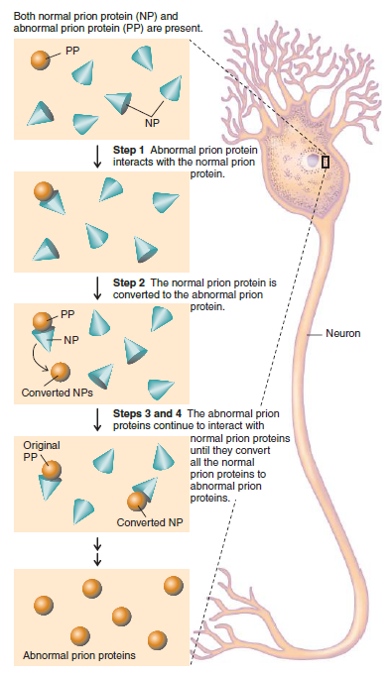
Proposed mechanism by which prions replicate. The normal and abnormal prion proteins differ in their tertiary structure. (Reproduced with permission from Nester EW, Anderson DG, Roberts CE, Nester MT
Common Human and Animal Prion Diseases
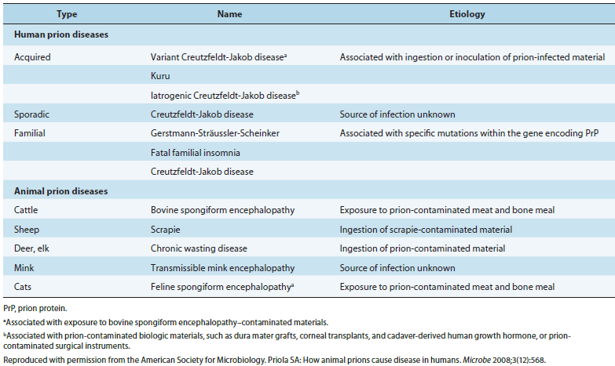

Distinguishing Characteristics of Viruses, Viroids, and Prions
